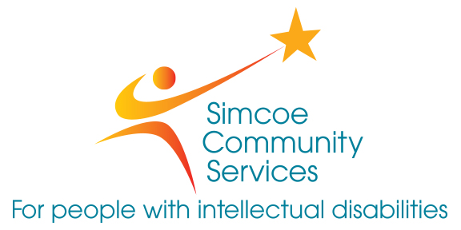
EMPLOYMENT OPPORTUNITIES

Simcoe Community Services is a non-profit, charitable organization. We are the largest provider of services for individuals with intellectual challenges in Simcoe County with over 575 employees and a budget of over $42 million. We are dedicated to supporting individuals and families to achieve their full potential through leadership, collaboration and advocacy by providing services that respond to community needs.

We are one of the largest community living organizations in Ontario providing services through a variety of programs which include; Accommodation Services and Community Support Services in the Barrie and Orillia areas.

We are presently accepting resumes for part time Support Workers to work in our Accommodation programs (group homes). In these positions you will provide supportive services to individuals with intellectual disabilities.

Part-Time Support Workers

Graduates of the Developmental Services Worker; Social Services Worker, ECE, C & Y Worker programs and Degree programs in Psychology, Sociology, Nursing, etc. will be considered for employment. You must be available to work all shifts including evenings, nights, weekends and holidays. A current clear criminal records check with a vulnerable sector screening check, pre-employment medical, valid class G driver’s license and reliable transportation are required.

If you have the qualifications and skills we are seeking and would like to join our team of skilled and dedicated employees please submit your resume to:

Simcoe Community Services
Human Resources Advisor
39 Fraser Court, Barrie, ON
L4N 5J5
Fax: (705) 726-6875
employment@simcoecommunityservices.ca

